MURI: TEMPLATION OF LONG-CHAIN SEQUENCE-CONTROLLED HETEROPOLYMERS

Seth R. Marder, Bernard Kippelen, Joseph W. Perry, MarcuS Weck
School of Chemistry & Biochemistry
School of Electrical and Computer Engineering
Center for Organic Photonics and Electronics
Georgia Institute of Technology
901 Atlanta Drive
Atlanta, GA 30332-0400

Phone: 404-385-6048
Fax: 404-385-6057
E-mail: seth.marder@chemistry.gatech.edu

June 30, 2008

MURI – Marder Group, Jun 2008

Carbazole-based Monomers and Polymers as Hosts for Phosphors
Figure 2. Synthesis of a bis(carbazolyl)biphenyl host norbornene monomer.
Our role within the MURI relates to the synthesis of building blocks, monomers, oligomers, and polymers with potentially interesting electronic and / or optical properties. Increasingly, organic light-emitting diodes (OLEDs) incorporate phosphorescent heavy-metal complexes, such as those of Ir and Pt, as lumophores in order that both singlet and triplet states resulting from electron and hole recombination can be harvested. Typically the heavy-metal complexes are dispersed within a host material with appropriate energy levels to facilitate the injection of both holes and electrons and with a sufficiently high triplet energy to allow for both singlet and triplet energy transfer to the heavy-metal guest of interest. Copolymerization of host and guest monomers offers a means of creating solution-processable emissive layers in which the possibility of phase separation is reduced and in which there is a possibility of controlling guest-guest and host-guest aggregation phenomena. One of the most widely used of these hosts is 4,4'-bis(carbazol-9-yl)biphenyl, CBP. We have previously reported a norbornene derivative of bis(carbazolyl)fluorene (Figure 1) and its copolymerization with platinum and iridium monomers.^{1,2}
Figure 1. Previously synthesized norbornene host monomer.
We have now synthesized a range of other carbazolyl monomers. Figure 2 shows the synthesis of a host monomer and the corresponding homopolymer containing a similar bis(carbazolyl)biphenyl building block. The monomers (and polymers) of Figures 1 and 2 are expected to show similar triplet energies,³ ionization potentials, and electron affinities. However, the different point of attachment of the polymer chain may alter the morphology of polymers and may affect host-guest aggregation. We have also synthesized polymerizable versions of the so-called mCP and mCPy host materials (Figures 3 and 4). The corresponding small molecules have been used as hosts for Ir and Pt phopshors. In particular, mCP has been shown to be a more effective host for blue Ir phosphors, such as iridium(III)bis[2-(4,6-difluorophenyl)pyridinato-N,C^{2'}]picolinate, than CBP due to its higher lying triplet energy.⁴ On the other hand, efficient white OLEDs have been made using emissive layers composed of a Pt phosphor guest, Platinum(II) 2-(4',6'-difluorophenylpyridinato-N,C^{2'})(pentane-2,4-dionato-O,O), which exhibits blue molecular emission and orange excimer emission, and a mCPy host.⁵ Improved performance relative to a mCP device was observed; one explanation advanced was that the electron-poor pyridine ring led to a more balanced injection of holes and electrons into the emissive layer. We are currently investigating the photoluminescence properties of host-guest systems composed of these polymers and metal-complex phosphors and use of these blends in organic light-emitting diodes. Based on these results, hosts with copolymerized with appropriate guest monomers.
Figure 3. Synthesis of mCP host norbornene monomer.

Figure 4. Synthesis of mCPy host norbornene monomer.

Phthalocyanine Side-Chain Monomer and Polymers
Phthalocyanines (Pcs) are another functionality of interest for organic electronic applications, particularly for use in solar cells, with CuPc being probably the most widely used. Most work with Pcs in solar cells has been limited to vacuum-processed materials. One possible method to facilitate solution processible Pcs would be to attach Pc building blocks to the side chain of a polymer. Moreover, ROMP offers the possibility of creating self-phase-segregating block polymers with donor a Pc block and another acceptor block. Pcs are also of interest for another DOD application: optical pulse suppression. The relatively weak linear aborption in the ca. 400-600 nm range, coupled with a strong triplet absorption in this range, makes examples in which high intersystem crossing rates can be achieved efficient reverse saturable absorbers in this wavelength range.⁶ For applications, films consisting of high chromophore densities are required; however, it is important that the linear and nonlinear optical films of these materials are not adversely affected by the tendency of Pcs to aggregate. Side chain polymers offer a possible means of incorporating high concentrations of Pcs in solution-processible films, while possibly also impairing Pc aggregation. We have begun synthetic studies aimed at such polymers using ZnPc as our initial building block, due to its simplicity and diamagnetism (and hence ease of NMR characterization). If successful, we anticipate that our methodology can be adapted to synthesize CuPc polymers for photovoltaic applications. For optical pulse supression, we can either use heavy-metal Pcs or copolymerize ZnPc with heavy-atom-containing comonomers, as shown in Figure 5. Figure 6 shows one possibility based on cocyclization of a norbornene-functionalized phthalonitrile with tert-butylphthalonitrile. Unfortunately, the desired product is similar in polarity and size to the tetra-(tert-butyl)-ZnPc side product, making separation by column chromatography and size-exclusion chromatography difficult. Figure 7 shows an alternative route to a norbornene-Pc monomer. Although this route requires an additional step, the polar alcohol functionality allows separation of a mono-functionalized Pc in moderate yield after two columns. We anticipate that this alcohol should be readily esterified to a norborene monomer as shown; this work is currently in progress.
Figure 6. Attempted synthesis of a norbornene-functionalized ZnPc.
Figure 5. Proposed Pc / iodinated copolymer for optical pulse suppression studies.
Figure 6. Alternative route to a norbornene-functionalized ZnPc.

References
(1) Cho, J.-Y.; Domercq, B.; Barlow, S.; Suponitsky, K. Y.; Li, J.; Timofeeva, T. V.; Jones, S. C.; Hayden, L. E.; Kimyonok, A.; South, C. R.; Weck, M.; Kippelen, B.; Marder, S. R. Organometallics 2007, 26, 4816.
(2) Kimyonok, A.; Domercq, B.; Haldi, A.; Cho, J.-Y.; Carlise, J. R.; Wang, X.-Y.; Hayden, L. E.; Jones, S. C.; Barlow, S.; Marder, S. R.; Kippelen, B.; Weck, M. Chem. Mater. 2007, 19, 5602.
(3) Marsal, P.; Avilov, I.; da Silva Filho, D. A.; Brédas, J. L.; Beljonne, D. Chem. Phys. Lett. 2004, 392, 521.
(4) Holmes, R. J.; Forrest, S. R.; Tung, Y.-J.; Kwong, R. C.; Brown, J. J.; Garon, S.; Thompson, M. E. Appl. Phys. Lett. 2003, 82, 2422.
(5) Williams, E. L.; Haavisto, K.; Li, J.; Jabbour, G. E. Adv. Mater. 2007, 19, 197.
(6) Perry, J. W.; Mansour, K.; Lee, I.-Y. S.; Wu, X.-L.; Bedworth, P. V.; Chen, C.-T.; Ng, D.; Marder, S. R.; Miles, P.; Wada, T.; Tian, M.; Sasabe, H. Science 1996, 273, 1533.

MURI: Templation of Long-Chain Sequence-Controlled Heteropolymers

Progress report, Period Covered Mar. – June 2008

Bernard Kippelen, Professor

School of Electrical and Computer Engineering

Georgia Institute of Technology

Testing of a norbornene based co-polymers containing a phosphorescent emissive center for OLED

During the last reporting period, we tested the electroluminescent properties of norbornene based co-polymers containing an emissive phosphor center where the iridium loading level has been varied (see 1 in Scheme 1). Here, we report the influence of the molecular weight and the linkage between the functional groups on the efficiency of organic light-emitting diodes based on these copolymers. Copolymers with three different molecular weights and copolymers with comparable molecular weight but varied linkage between the polymer backbone and the functional groups were synthesized and purified.

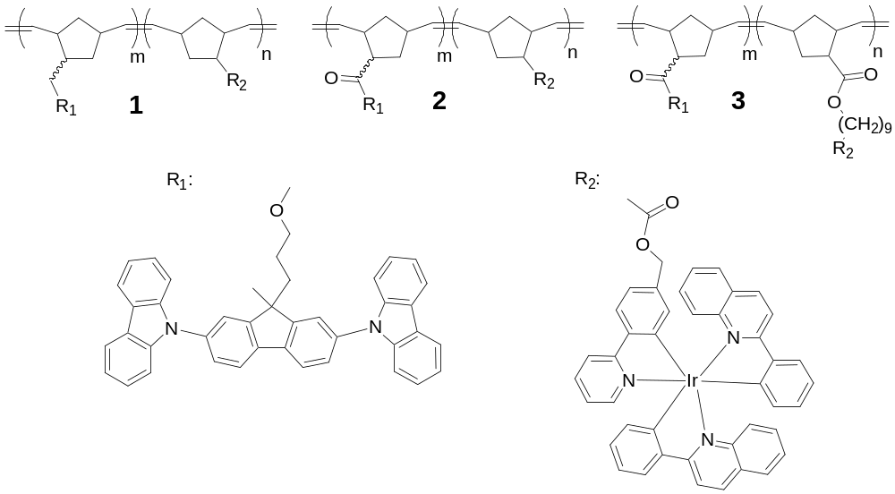

Scheme 1: Structure of the norbornene containing copolymers with different linkage between the functional groups.

For hole-injection into the host-guest system, we used a TPD based polymer (4, Poly-TPD-F₂, see Scheme 2) that was developed by our team [Chem. Mater. 2003, 15, 1491]. This polymer can be photo-crosslinked under UV illumination, which allows the fabrication of multilayer devices from solution. Furthermore, to increase the efficiency of the devices, a hole-blocking/electron-transport layer of BCP was thermally evaporated on the phosphorescent copolymers, and a LiF/Al cathode was used for good electron-injection.

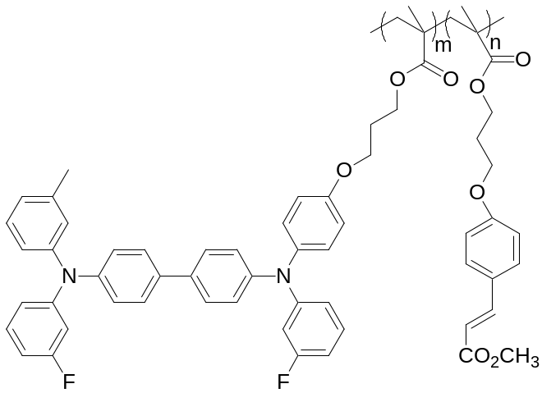

Scheme 2. Structure of the crosslinkable hole-transport polymer 4.

Table 1. Characterization of copolymers with peak maxima of solid-state photoluminescence and electroluminescence spectra, plus external quantum efficiency and luminous efficiency at 100 cd/m² for devices based on phosphorescent copolymers with different molecular weight and different linkages between the side groups and the polymer backbone. The device structure was ITO/4 (35 nm)/(1-3) (20-25 nm)/BCP (40 nm)/LiF (1 nm)/Al.

Polymer | m:n  (mol%) | M_{n}  (×10³ g/mol) | PDI | λ_{max,PL} (nm) | λ_{max,EL} (nm) | EQE (%) | Luminous efficiency (cd/A)
1 | 89:11 | 19.0 | 1.29 | 594 | 600 | 2.9±0.3 | 3.9±0.4
1 | 92:8 | 70.0 | 1.33 | 590 | 602 | 3.2±0.3 | 4.9±0.4
1 | 90:10 | 238.0 | 1.47 | 591 | 607 | 1.5±0.1 | 2.0±0.1
2 | 90:10 | 16.0 | 1.31 | 592 | 605 | 3.9±0.3 | 5.3±0.4
3 | 90:10 | 20.0 | 1.21 | 594 | 603 | 4.5±0.5 | 8.0±0.9
3 | 95:5 | 16.5 | 1.21 | 595 | 597 | 4.9±0.4 | 8.8±0.7

External quantum efficiencies (EQEs) and luminous efficiencies at 100 cd/m² for the devices fabricated with different copolymers are listed in Table 1. The efficiency of devices with copolymers of different molecular weight was found to decrease for the copolymers with the highest molecular weight (238 kDa). However, no significant difference in efficiencies could be found when the molecular weight was varied between 19 kDa and 70 kDa.
The study of the dependence of the efficiency of OLEDs on the linkage between the functional groups of the emissive polymers showed an increased efficiency for devices with copolymer 2 and 3 compared to copolymer 1. By replacing the ether group that connects the bis(carbazolyl)fluorene group to the polymer backbone with an ester group, the efficiency was 1% higher at 100 cd/m² than for the copolymer 1. Finally, inserting an elongated linkage between the iridium complex and the polymer backbone (3) increased the EQE by another 0.6%.
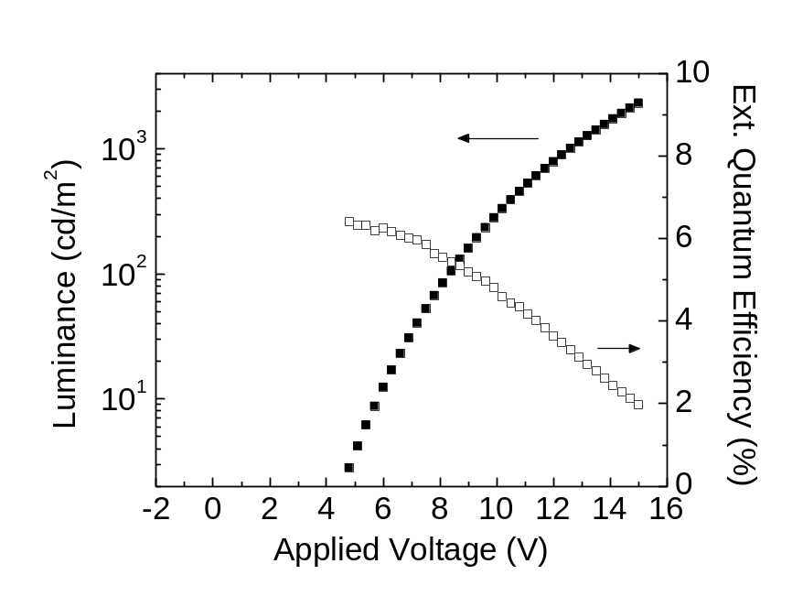
Figure 1. External quantum efficiency as a function of the loading level of the iridium complex in the copolymer for OLEDs with device configuration ITO/ 1 (35 nm)/ (2-8) (20-25 nm)/BCP (40 nm)/LiF (1 nm)/Al.

Combining the results discussed from this reporting period with the previous one where the highest efficiencies were observed in copolymers with an iridium loading level of 5 mol%, a copolymer with an elongated ester linker and an iridium complex concentration of 5 mol% was synthesized. The external quantum efficiency measured in an OLED based on this copolymer as emissive layer was the highest of the present study: 4.9±0.4% and 8.8±0.7 cd/A at 100 cd/m² (Figure 1). This result validates the trends that were established through our studies in which we varied different properties independently. Given the low value (10% in toluene) of the photoluminescence quantum yield of the orange iridium emitter that was incorporated in these copolymers [Chem. Mater. 2007, 19, 5602], the measured EQE of 4.9% in devices with this optimized copolymer indicates that the electroluminescent properties of this copolymer are nearly optimized.
During the next reporting period, we will report on a crosslinkable emissive layer based on the optimized copolymer above and we will show the fabrication of OLEDs where all organic layers have been deposited from solution.

QUARTERLY REPORT FOR

THE CALIFORNIA INSTITUTE OF TECHNOLOGY

TRANSIENT ABSORBANCE AND OPTICAL POWER LIMITING OF OSMIUM PHTHALOCYANINES

Joseph W. Perry, Matthew M. Sartin, Matteo Cozzuol
School of Chemistry & Biochemistry
Georgia Institute of Technology
901 Atlantic Dr. NW
Atlanta, GA 30332-0400

Phone: 404-385-6046
Fax: 404-385-6057
E-mail: joe.perry@chemistry.gatech.edu

June 19, 2008

OBJECTIVE:
Understand how to improve the performance of opto-electronic materials by using molecules with well-defined structures.

APPROACH:
Investigate multichromophoric systems for photoinduced charge generation or energy transfer and optical absorption. Perform spectroscopic characterization of charge generation, transient optical properties, and optical limiting properties.

MILESTONES:
To develop materials for efficient charge carrier generation or energy transfer and long lifetimes. To develop high sensitivity, broadband, high dynamic range nonlinear absorptive materials for optical limiting.

ACCOMPLISHMENTS

Performed optical power limiting and transient absorption spectroscopy on two osmium naphthalocyanines that showed optical power limiting at 532 nm in solution. Each has a strong, additional, transient band at 425 and 450 nm, respectively.

RESULTS

We have performed transient and nonlinear optical studies on a pyridine-substituted and a triphenylphosphine-substituted osmium naphthalocyanine (OsNcPy and OsNcPPh₃), whose structures are shown in Fig. 1. These were synthesized by the Marder group. The linear electronic absorption spectra in toluene are shown in Figure 2. The spectrum of OsNcPy shows a Q-band absorption at 695 nm and a minimum at 550 nm. The OsNcPPh₃ also shows a Q-band absorption at 699 nm and a minimum at 550 nm; however, the absence of the charge transfer band seen in the OsNcPy makes the transmittance window larger for OsNcPPh₃.

Optical power limiting data were taken on OsNcPy and OsNcPPh₃ in toluene using an f/5 optical geometry, 532 nm, 5 ns laser pulses, and a 10 Hz repetition rate, as shown in Fig. 3. Significant optical limiting was observed at both wavelengths. The

initial transmission at 532 nm was 70%, and the observed suppression (T_{linear}/T_{Emax}) was 1.04 at 100 μJ. Temporary equipment problems have prevented the use of higher energies (usually up to 2 mJ), where we expect to see greater suppression, and suppression was unobservable in OsNcPy under these conditions. Figure 3b shows the optical limiting behavior of a sample with 30% transmittance at the excitation wavelength, in which the suppression is more apparent. The response for OsNcPPh₃ was compared with that of an InClPc(t-butyl)₄ solution in toluene with a 70% transmission at 532 nm where the limiting data were taken; InClPc(t-butyl)₄ is known to be a high performance optical limiting dye at this wavelength. The suppression of the InClPc(t-butyl)₄ solution was observed to be 15 at 532 nm in the same geometry.

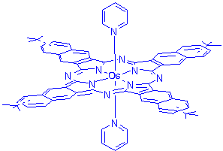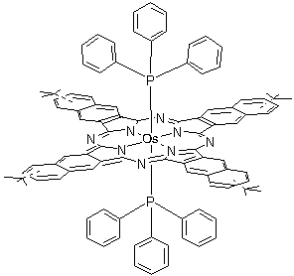

(a) (b)
Figure 1. Structure of (a) OsNcPy and (b) OsNcPPh₃.
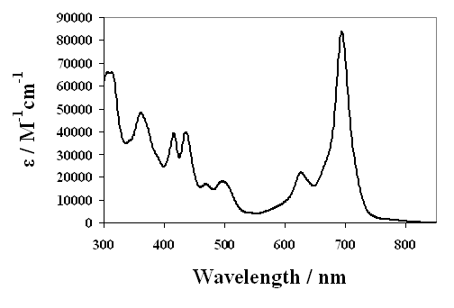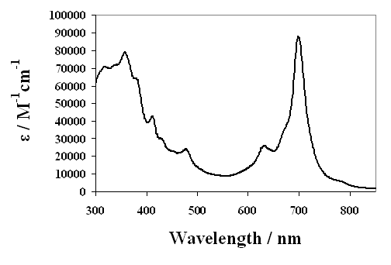
(a) (b)
Figure 2. Visible absorption spectra of (a) OsNcPy and (b) OsNcPPh₃.

In order to obtain some insight into the mechanism of the optical limiting, we performed nanosecond transient absorption spectra on OsNcPy and OsNcPPh₃ in toluene. The transient difference spectra are shown in Fig. 4. Transient bleaching of the Q-band and the shorter wavelength absorption band is observed. Both molecules exhibit a weak induced absorption at ~ 560 nm, which is attributed to absorption from the triplet state. If unit intersystem crossing efficiency is assumed, the extinction coefficients of these transients at 532 nm are 5×10³ M⁻¹cm⁻¹ for OsNcPy and 1.0×10⁴ M⁻¹cm⁻¹ for OsNcPPh₃. They exhibited a stronger absorbance at short wavelength. Again, if 100% intersystem crossing is assumed, ε = 7.4×10⁴ M⁻¹cm⁻¹ at 455 nm for OsNcPy, and 2.3×10⁵ M⁻¹cm⁻¹ at 425 nm for OsNcPPh₃. This shorter wavelength absorbance probably indicates a transition to a higher excited triplet state.

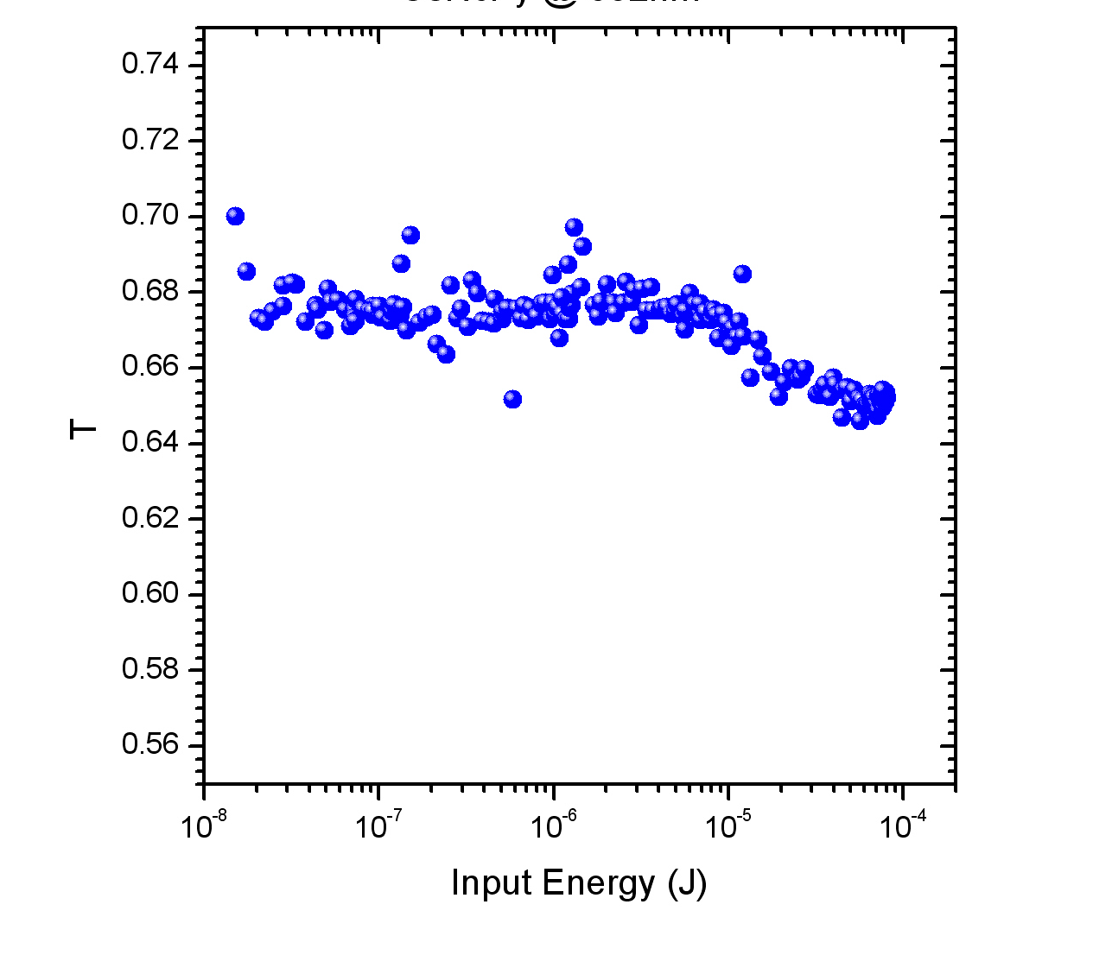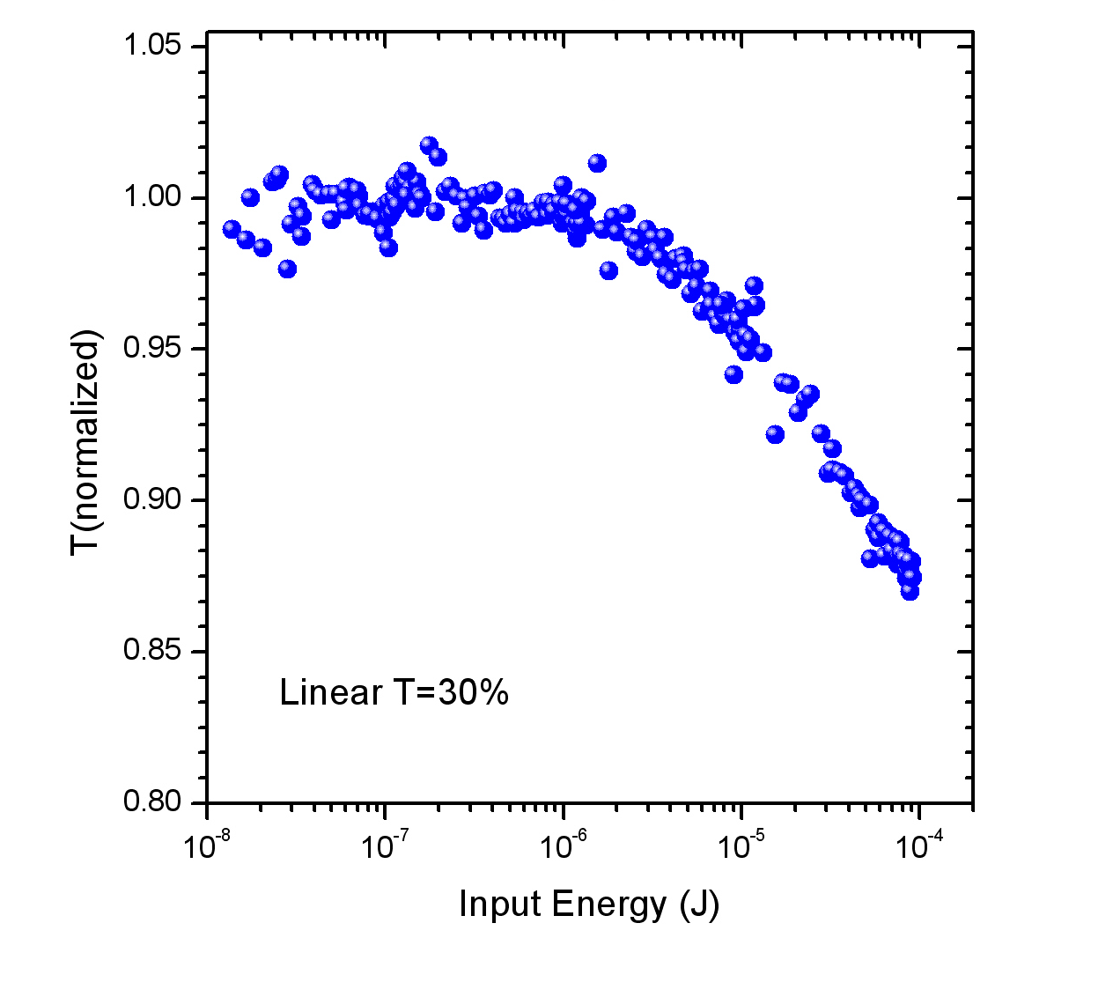
(a) (b)
Figure 3. Optical power limiting data for OsNcPPh₃ in toluene excited at 532 nm. (a) 70% transmittance (b) 30% transmittance

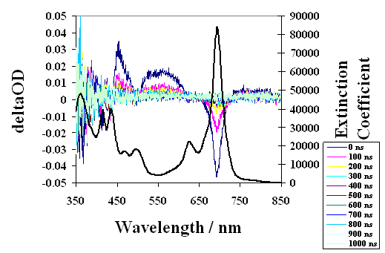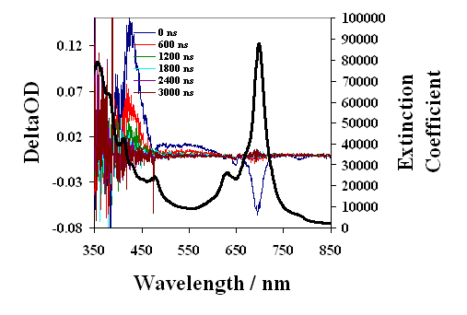
(a) (b)
Figure 4. Transient absorption spectrum (a) OsNcPy and (b) OsNcPPh₃ in toluene excited at 680 nm (OD = 0.2).

CONCLUSIONS

We have shown that two osmium naphthalocyanines show optical limiting at ~532 nm for nanosecond laser pulses consistent with a reverse saturable absorption mechanism. In addition to the photoinduced absorbance at 560 nm, both molecules exhibit a stronger, short wavelength transient absorbance (455 nm for OsNcPy and 425 nm for OsNcPPh₃) that probably results from an accessible higher triplet state.

In future work, we will attempt to further characterize the spectroscopy of the molecules. Additionally, we can repeat the optical limiting experiments when the technical difficulties with our current system are resolved, to obtain a clearer representation of the optical suppression capabilities of these materials. More materials of this sort will be analyzed in the future.

Weck group Template project Q2/2008

Covalent linkage-based template polymerization. In the last quarter, we concentrated our efforts on synthesizing covalent-based templates (synthetic scheme below). Hydrazide-containing monomer 3 was prepared starting from 11-aminoundecanoic acid in 3 steps. exo-Norbornene acid was esterified with 3,3-diethoxy-1-propanol using DCC and DMAP to afford monomer 4. Polymer 6 was synthesized by polymerization of monomer 4 using 5 mol % of Grubbs’ first-generation initiator (M_{n} = 6 000, PDI = 1.33) and subsequent hydrogenation on the poly(norbornene) backbone. Monomer 3 was attached to aldehyde-containing poly(norbornene) template generated in situ from 6 to form hydrazone compound 7 which was then polymerized quantitatively using Grubbs’ third-generation initiator in chloroform. However, isolated 8 was not soluble in common organic solvents such as dichloromethane, THF, DMF, and DMSO. The insolubility of 8 can be attributed to the cross-linking resulting from the poly(norbornene) double bonds and residual initiators. In order to overcome this problem, hydrogenation on poly(norbornene) backbones of daughter polymers was attempted to yield fully hydrogenated double stranded poly(norbornene) 9. Unfortunately, 9 was insoluble in common organic solvents precluding characterization. We are currently developing synthetic strategies to synthesize and fabricate soluble analogues.

Scheme 1. Synthesis of template 6 and hydrazone-based template polymerization.

